**WebSphere JMS Front Side Handler**

**Configuring JMS in WebSphere Application Server:**

Step 1: Creating a bus.

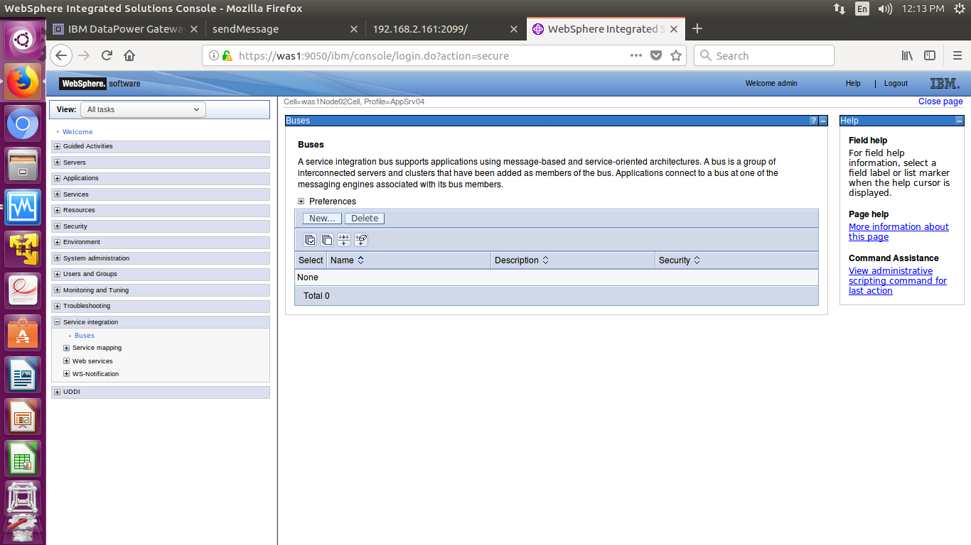

Click on New button and create a new bus.

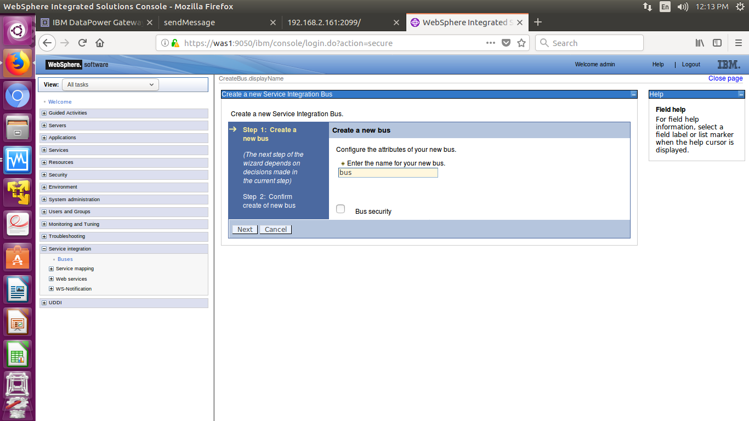

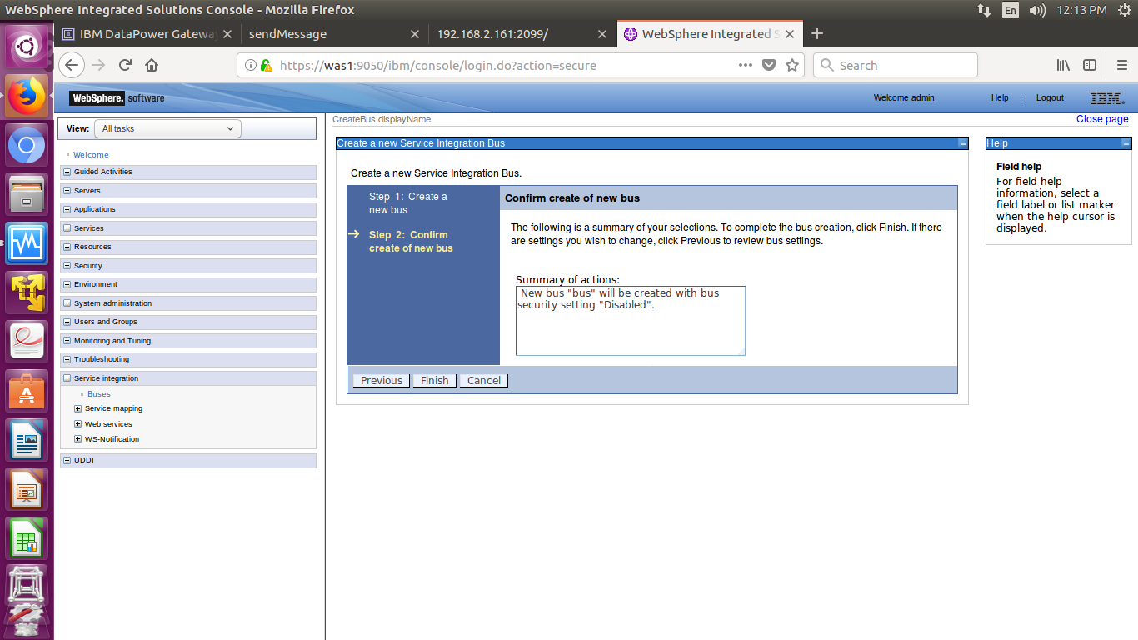

Click on the Finish button and now the bus has been created.

Step 2: Create a bus member.

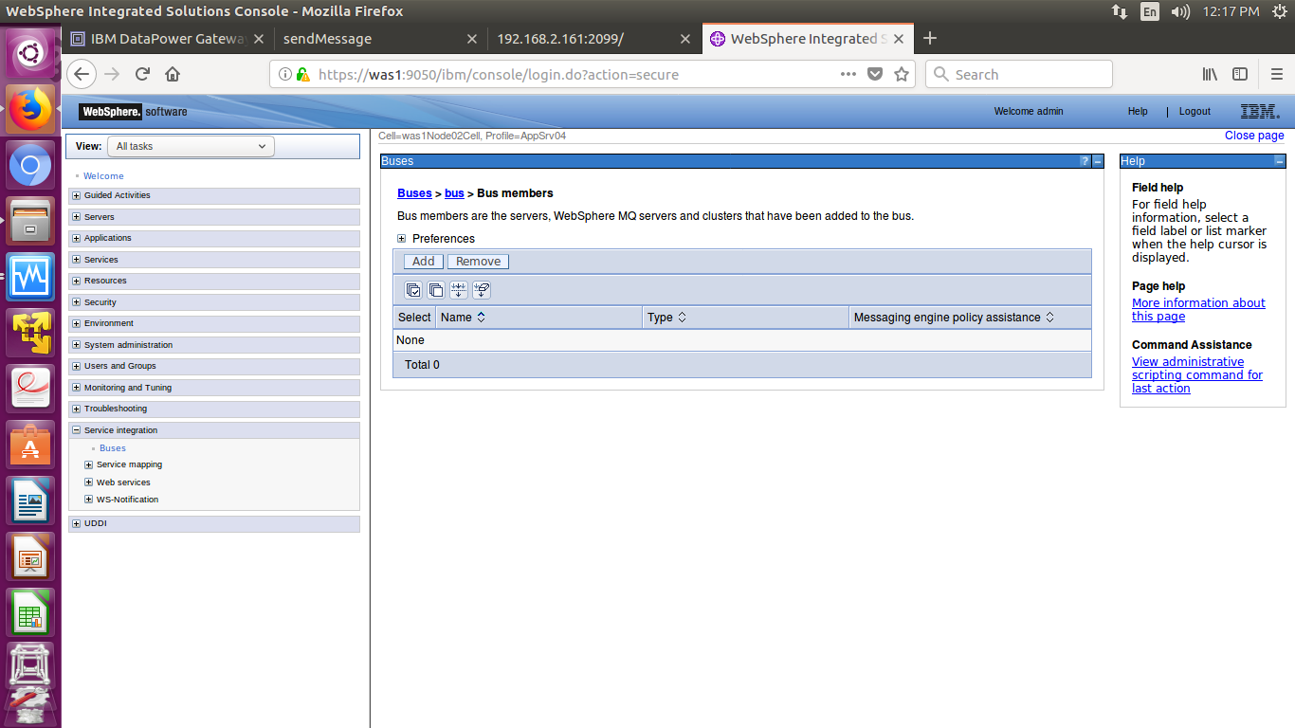

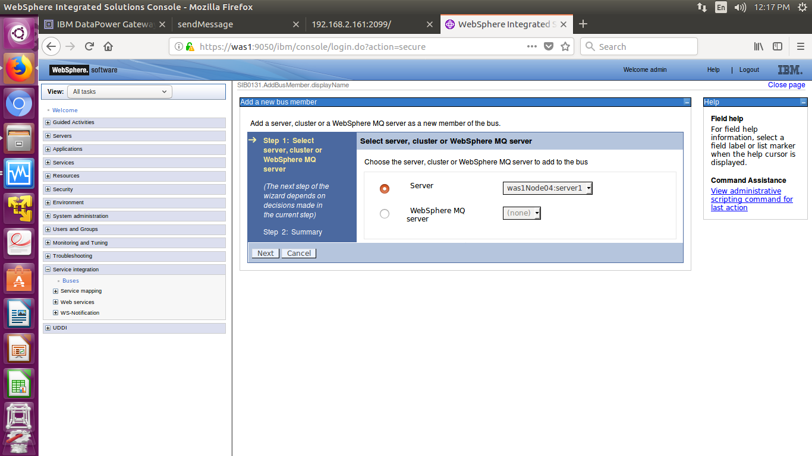

Check the server, which server you are using for JMS.

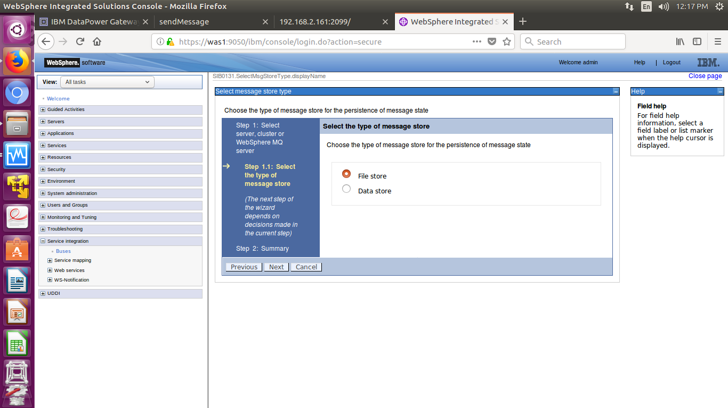

Use file store type.

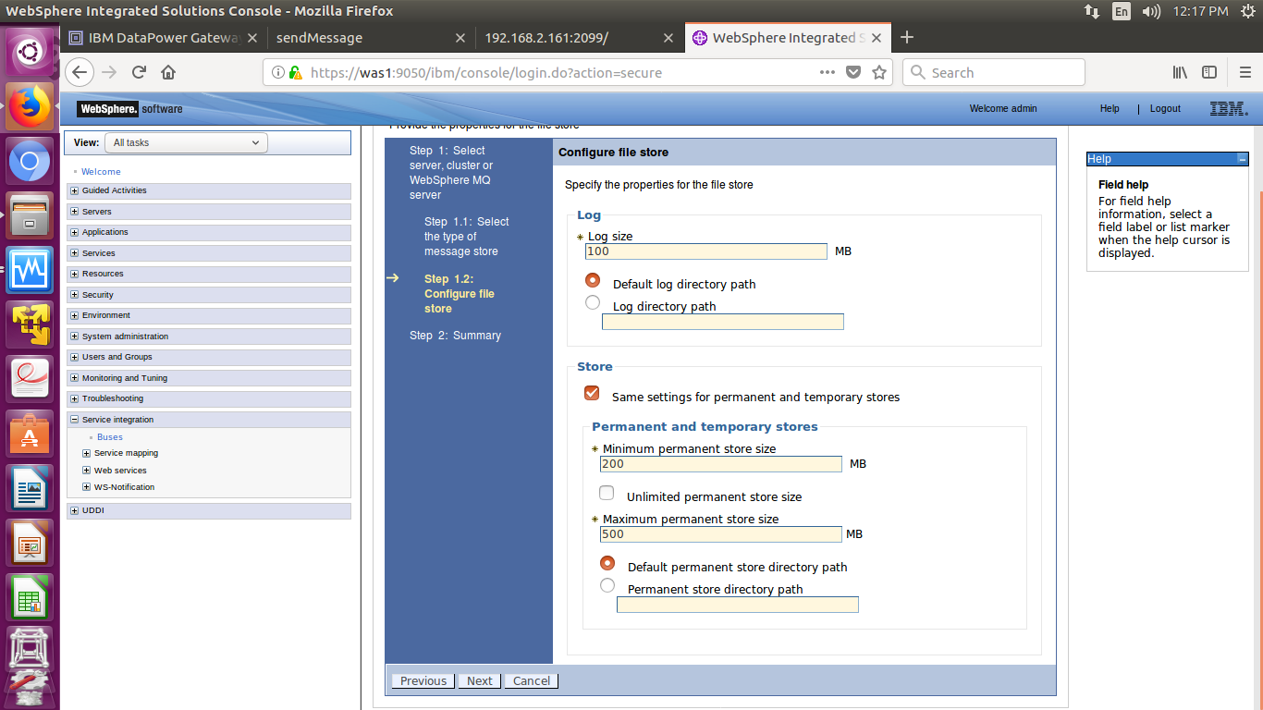

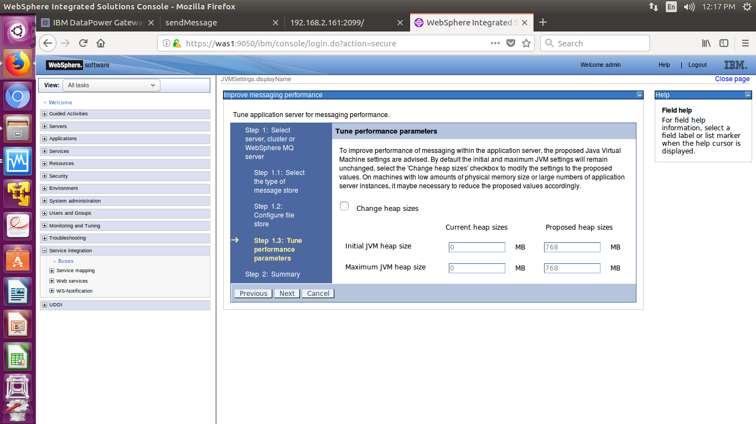

Continue with default heap sizes.

Step 3: Create a Destination Queue.

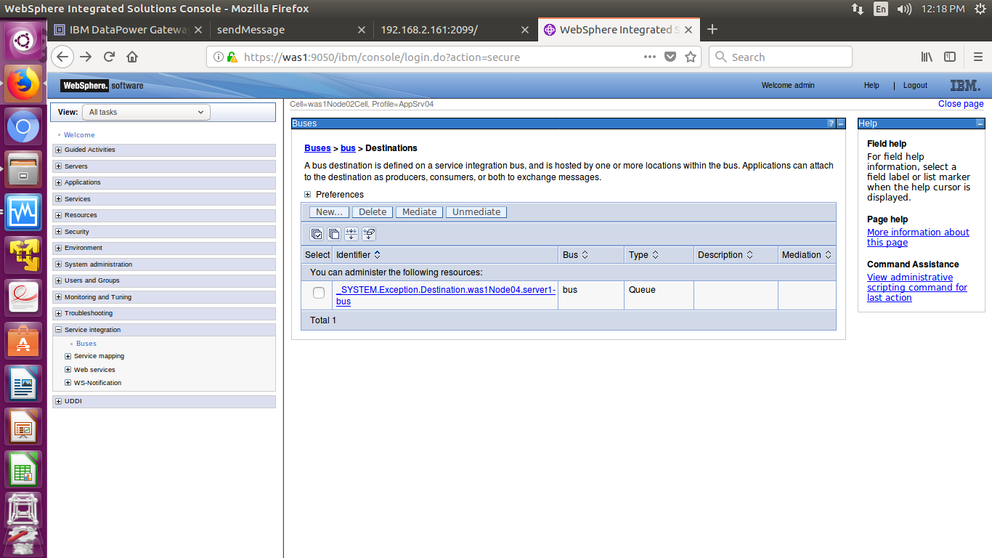

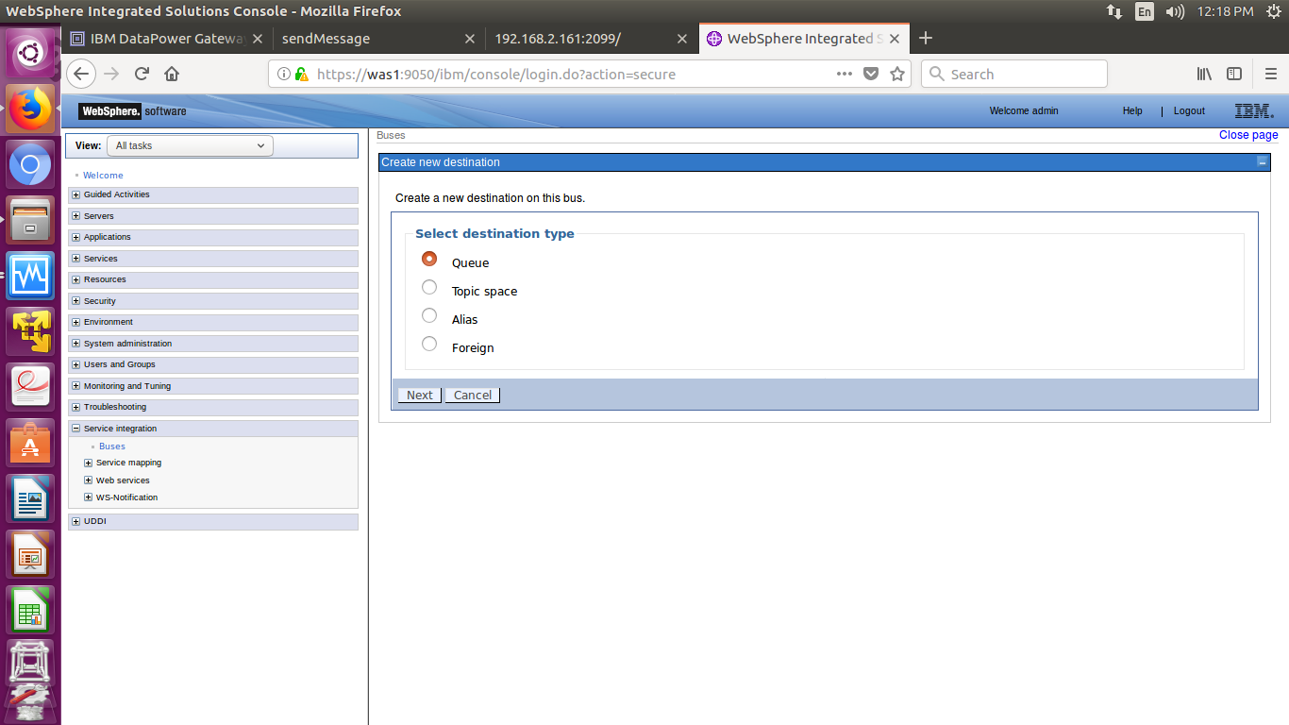

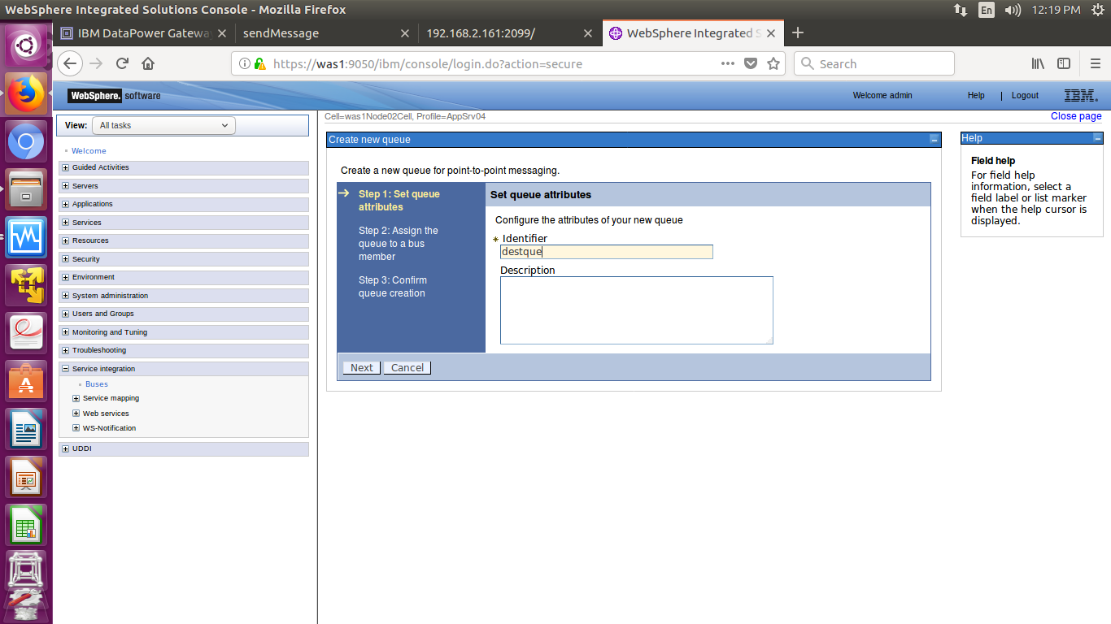

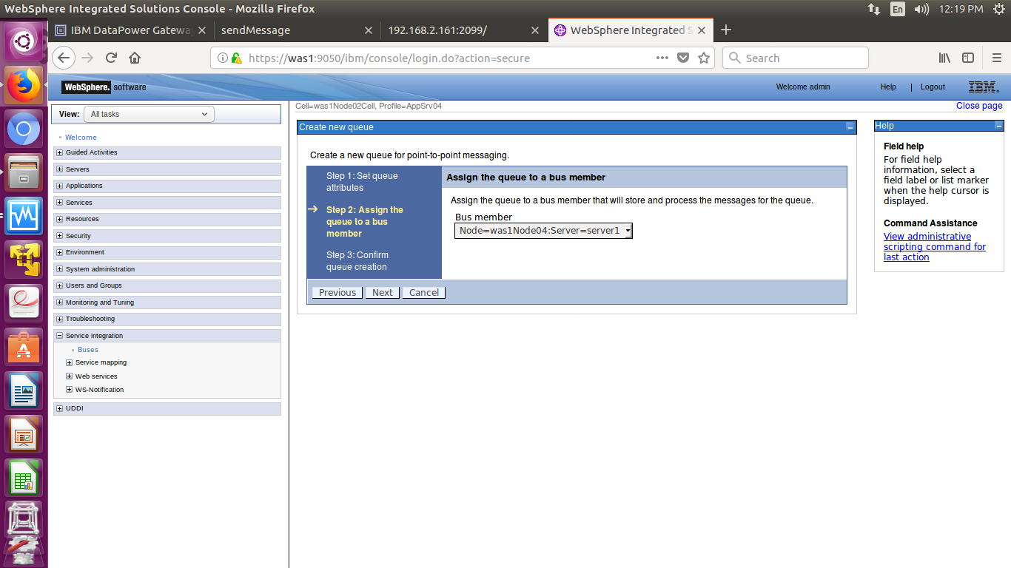

Select the server scope where you created bus member.

Step 4: Creating queues and connection factories.

Go to Resources🡪JMS🡪JMS providers.

Use Default JMS provider and create two queues and a queue connection factory.

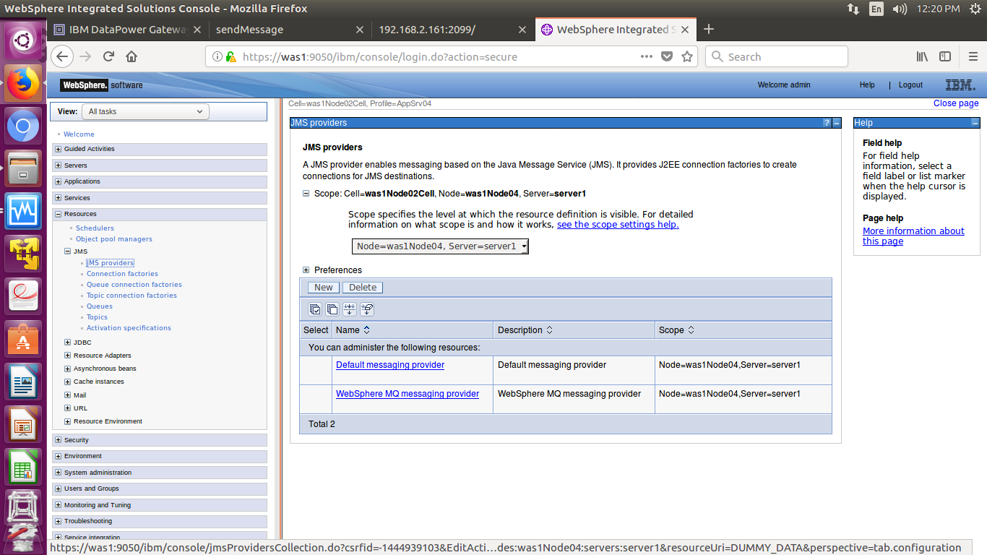

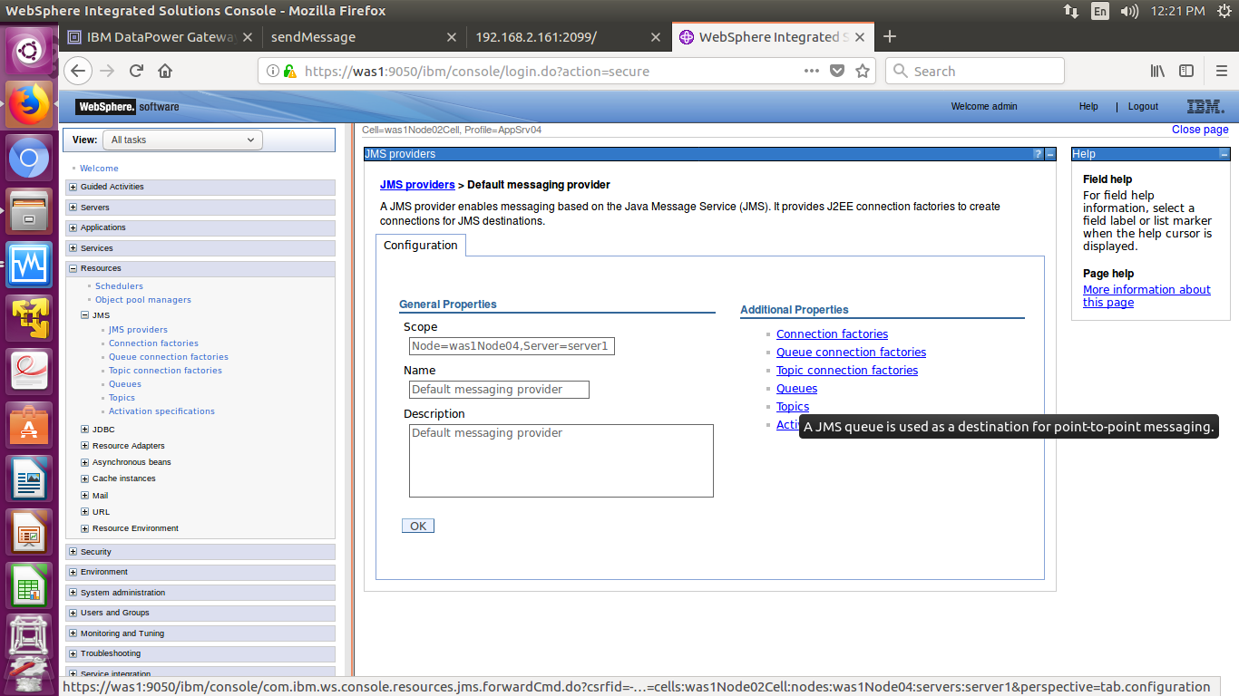

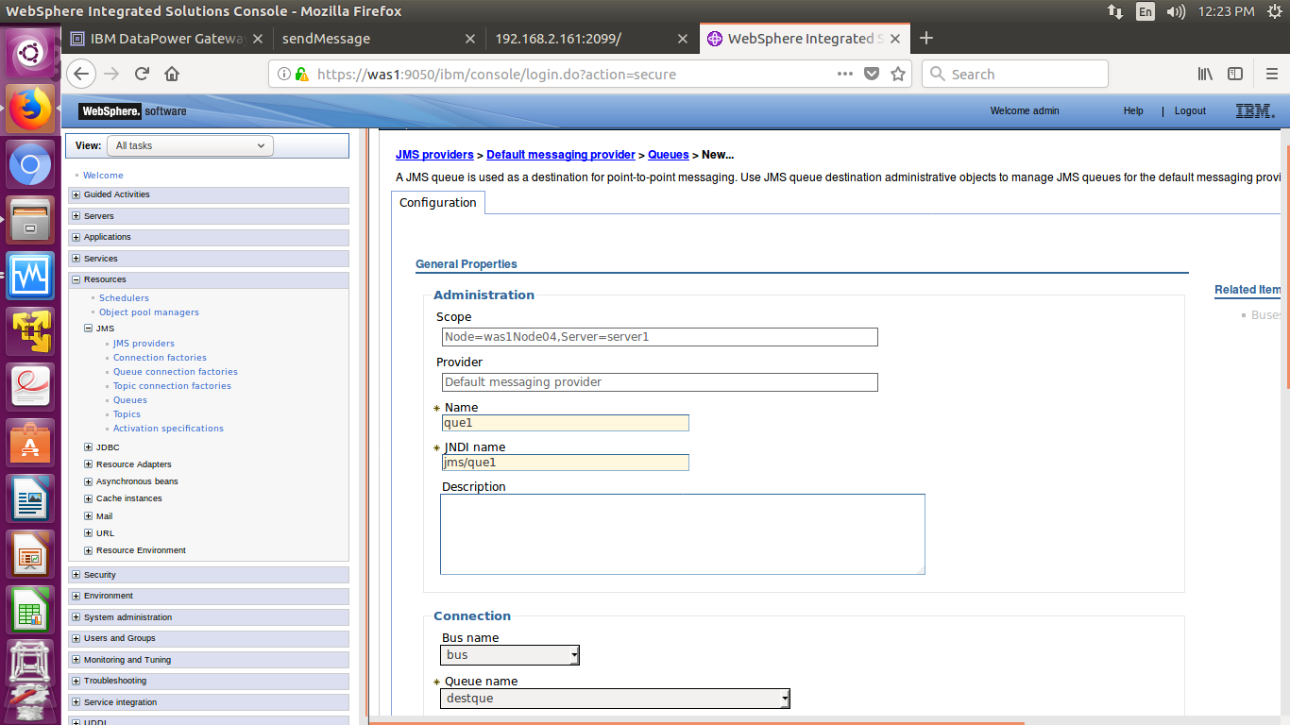

In the connection section give Queue name as Destination queue you have created.

Create another queue.

Now create a connection factory.

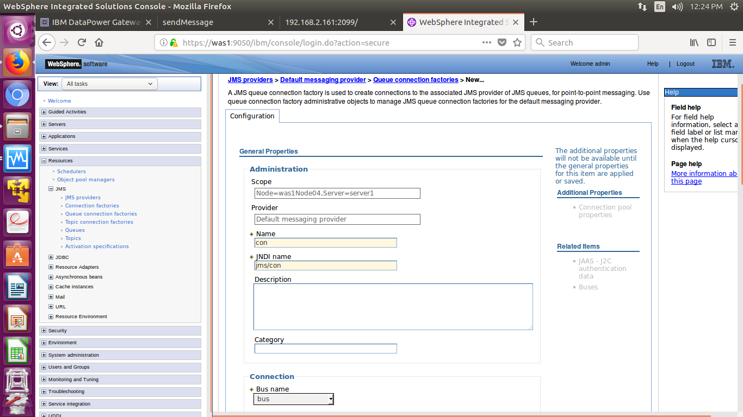

Step 5: Deploy an application in WAS and start the application.

Applications🡪 New Application🡪 New Enterprise application.

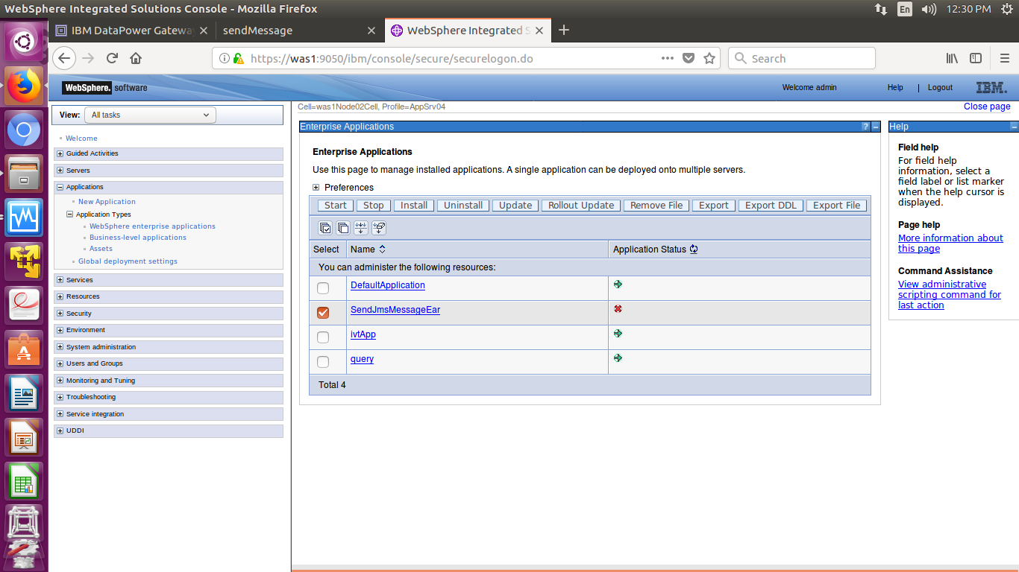

Go to Environment🡪Virtual hosts🡪 Alias

The port on which the application is running is available here.

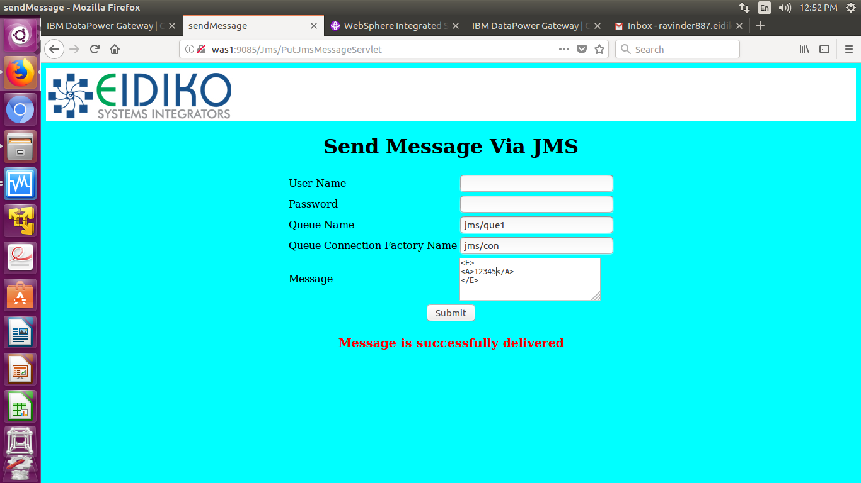

Use JNDI names to send a message.

**Configuring JMS Front side Handler using Multi-Protocol Gateway Service:**

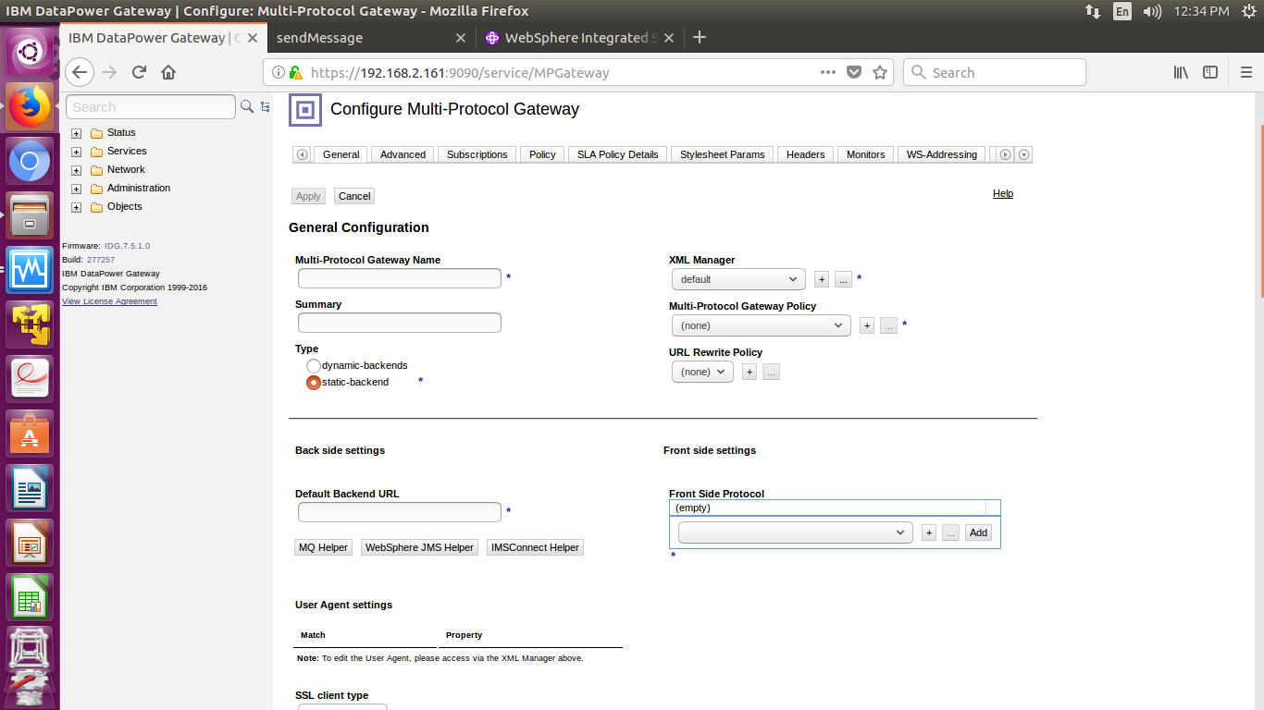

Use default Multi-Protocol Gateway Policy.

Create a Web Sphere JMS front side handler.

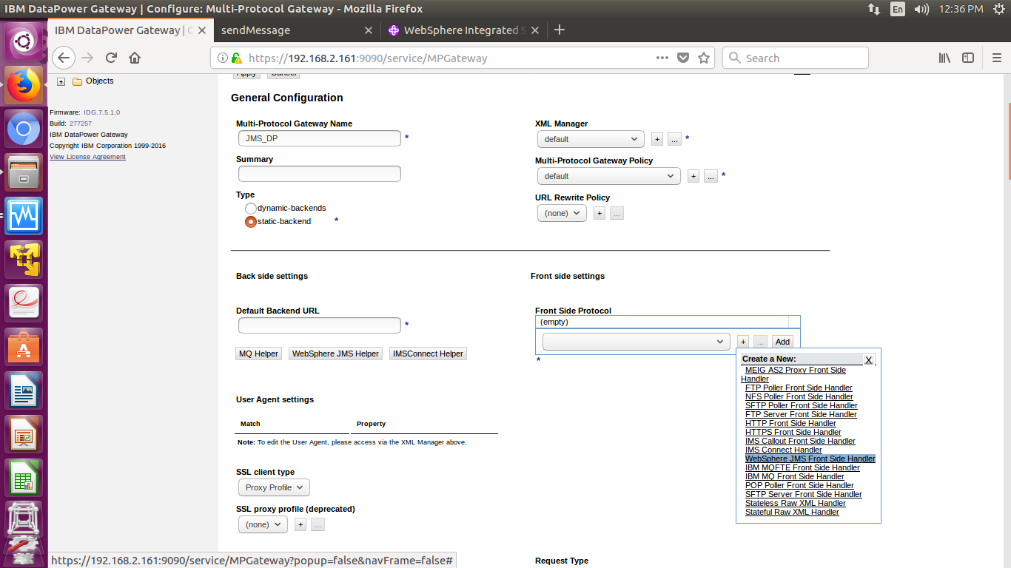

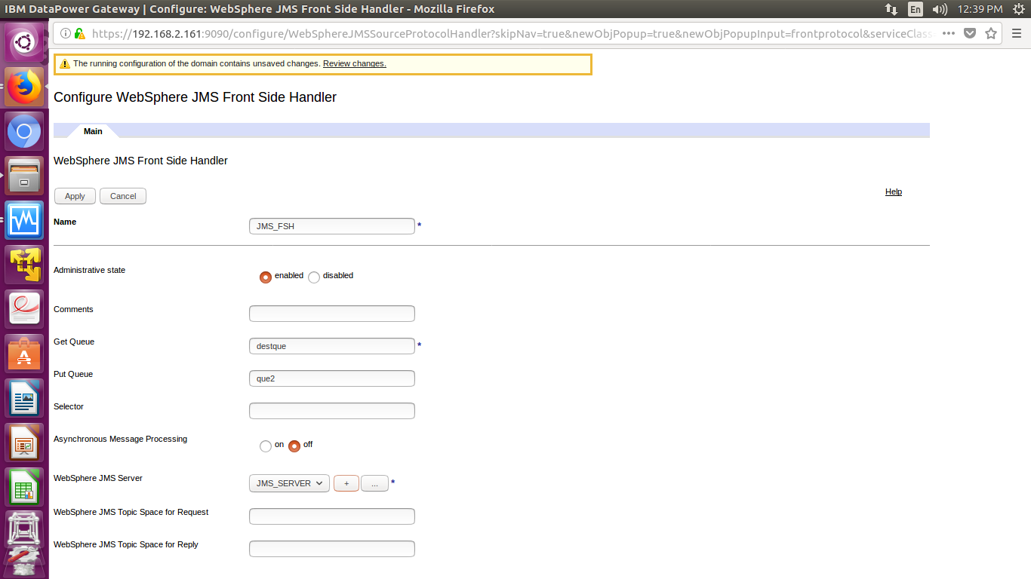

Create a WebSphere JMS Server.

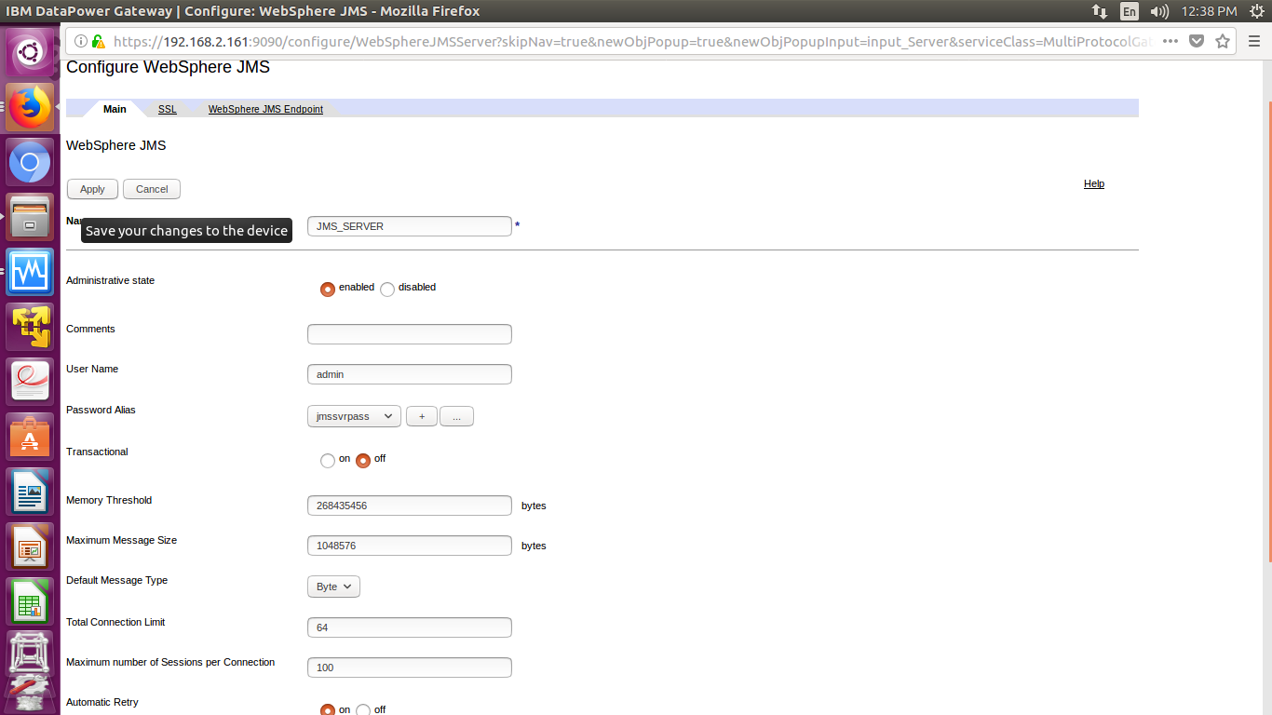

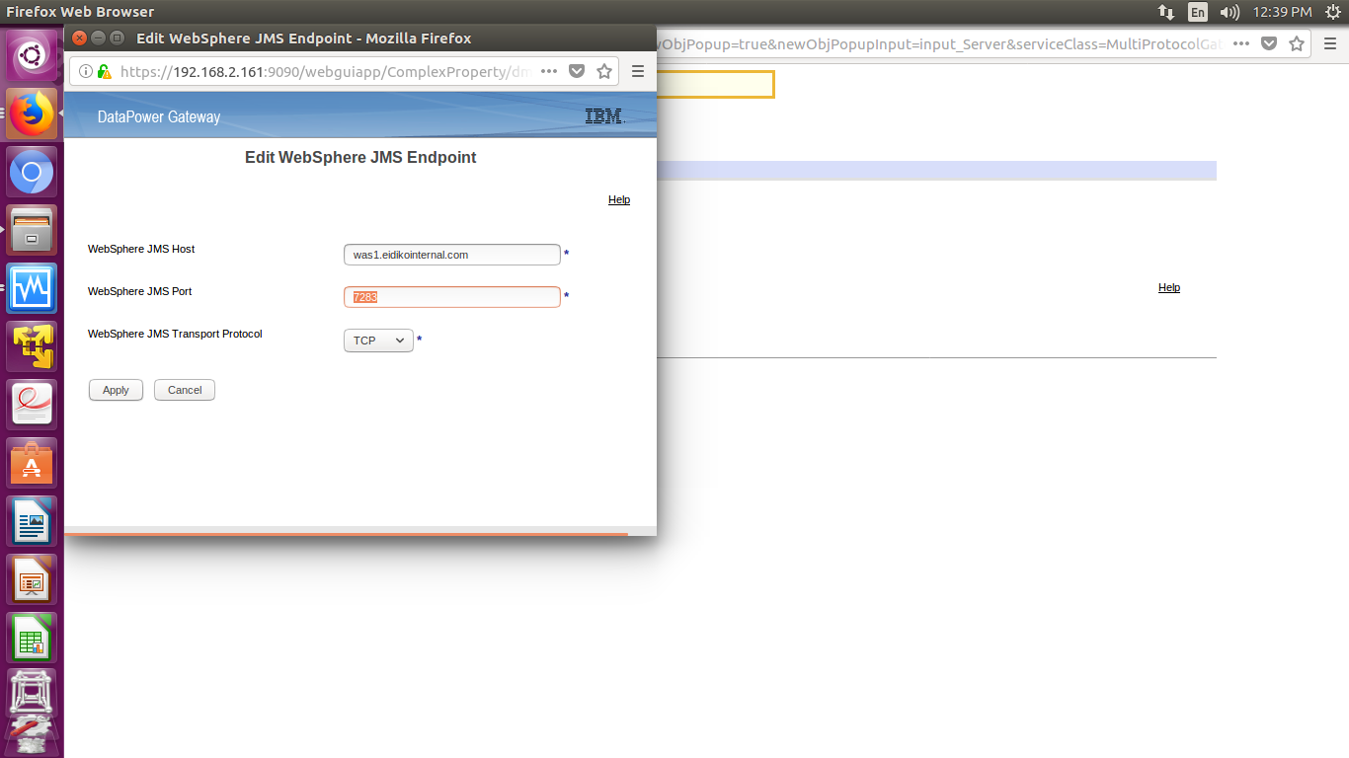

WebSphere JMS port is available in WAS

Open WAS console 🡪 Servers🡪 WebSphere Application Servers🡪 Server1🡪 Ports.

Use SIB Endpoint port.

Create an XML Firewall and use it’s service as Backend URL in Multi-Protocol Gateway Service.

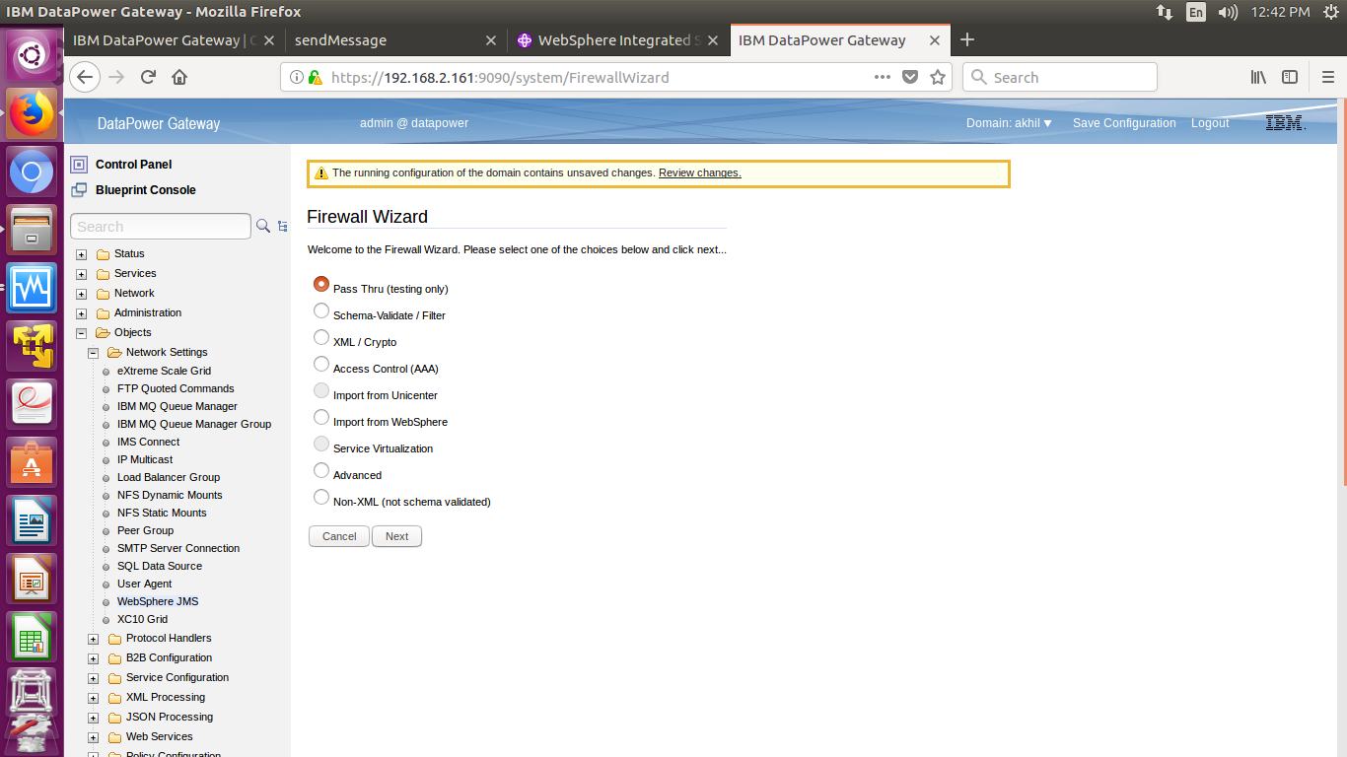

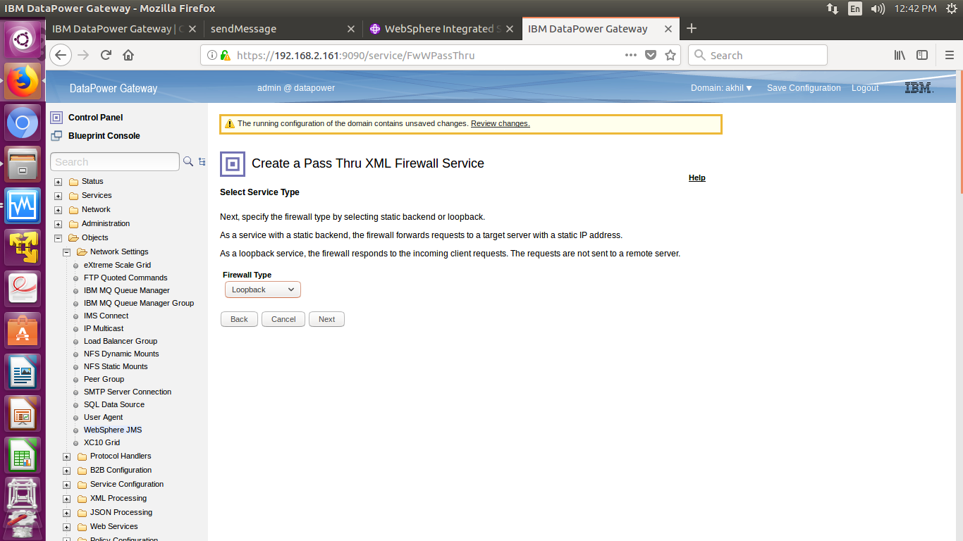

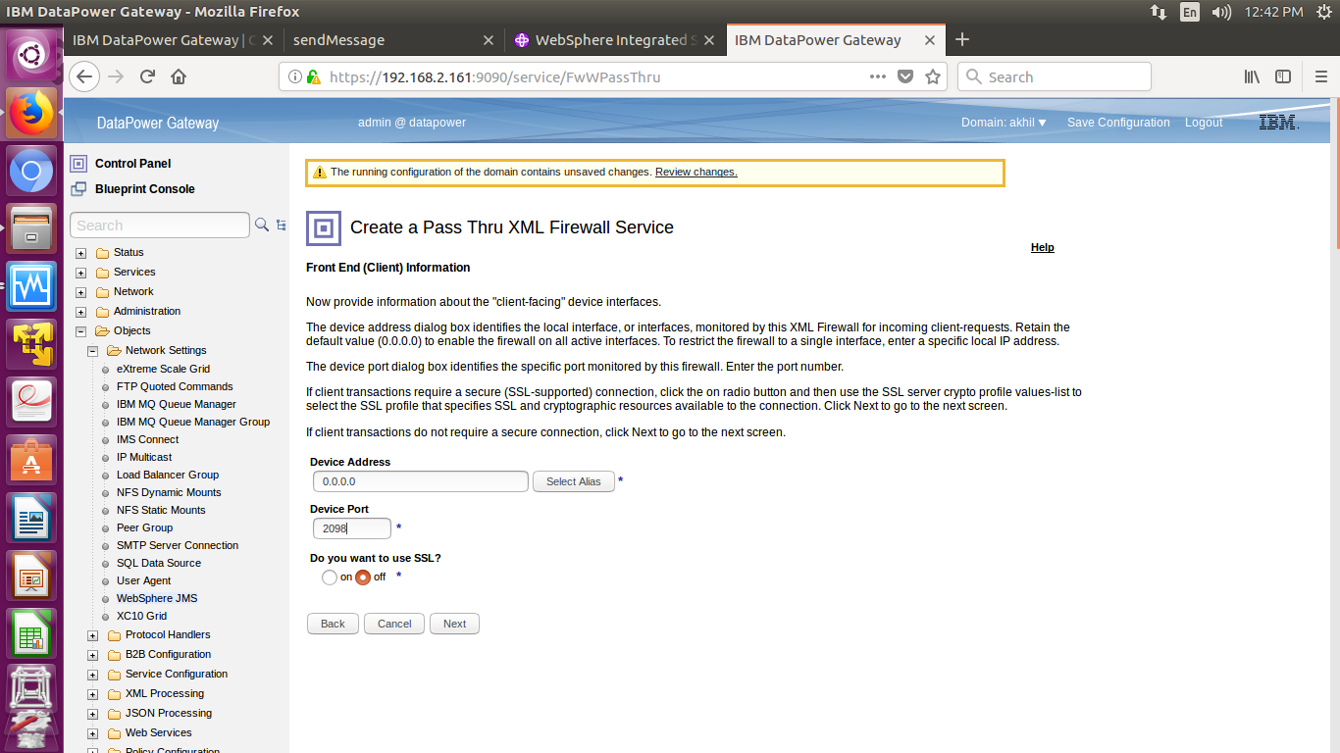

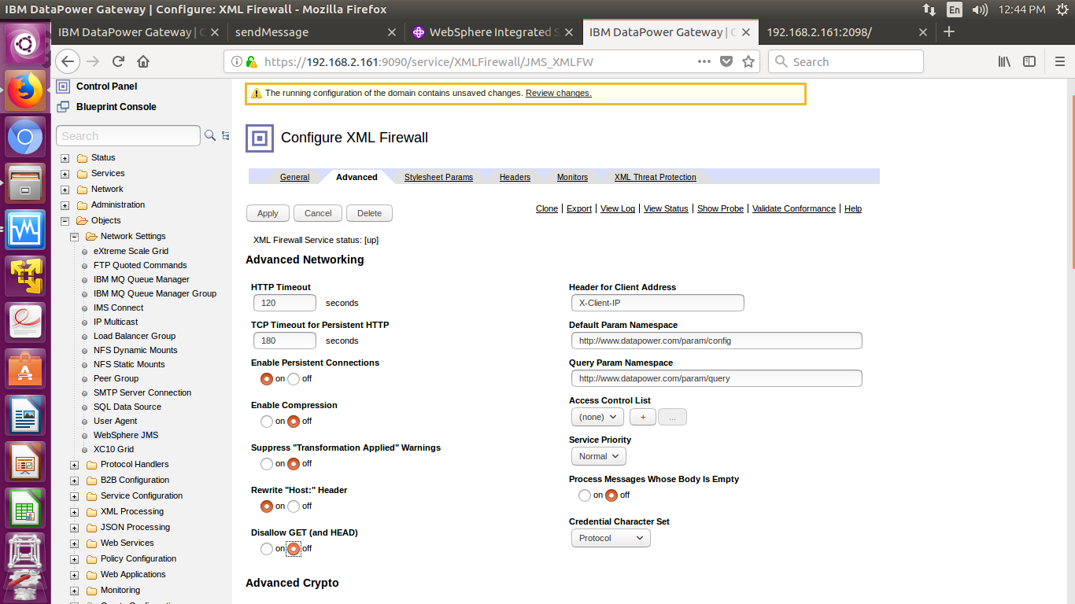

Allow GET method by turning off Disallow GET in Advanced Section.

Use this service as Backend URL in Multi-Protocol Gateway Service.

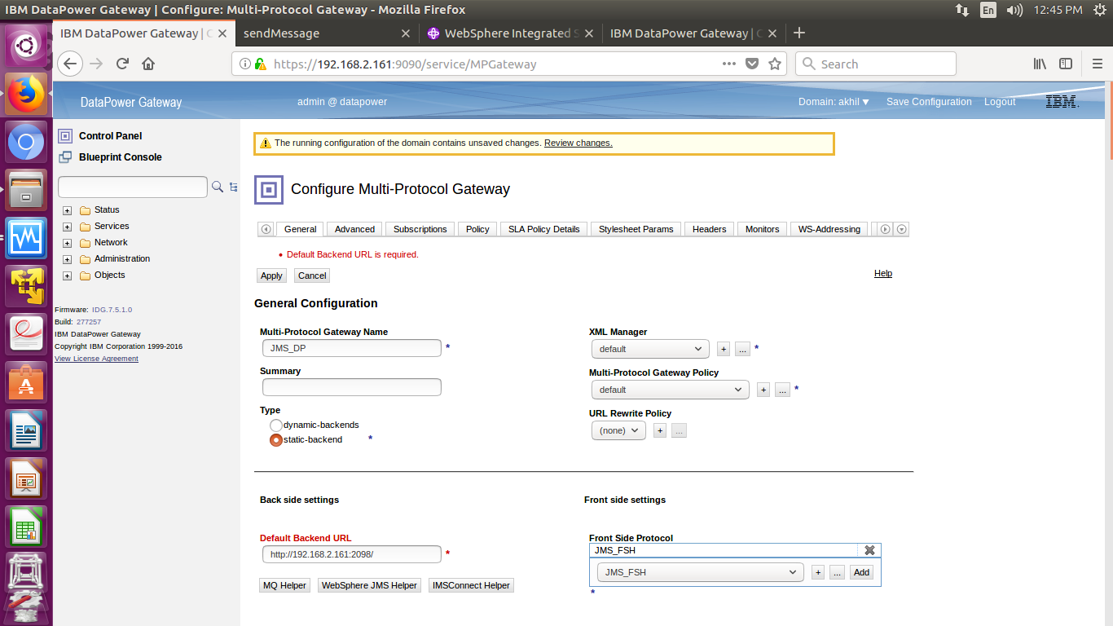

Now save the configuration.